Sovereign Mesh AI EHR Integration Post 3
As a continuation of my previous post on Sovereign Mesh Neural Net development for AI EHR systems, this example is using the InterSystems’ AI EHR ecosystem architecture. West Virginia is used as the local state where legislature WV-SB17 Metadata Enforcement is tantamount to the discussion. Nevertheless, Sovereign Mesh integration will accommodate any EHR system in the cloud, or on-premise or both (i.e. Hybrid) bearing in mind, we are building a decentralized enterprise for AI EHR Neural Net systems.

As an architect, one will create a Sovereign Mesh Master Document which is designed to serve as a primary "Source of Truth" for stakeholders, hospital boards, and SOC 2 auditors. It bridges the gap between high-level architectural vision and rigorous compliance.
Taking for example an interpreted but qualified version of the InterSystems’ HealthShare and IRIS AI EHR ecosystem shown here:

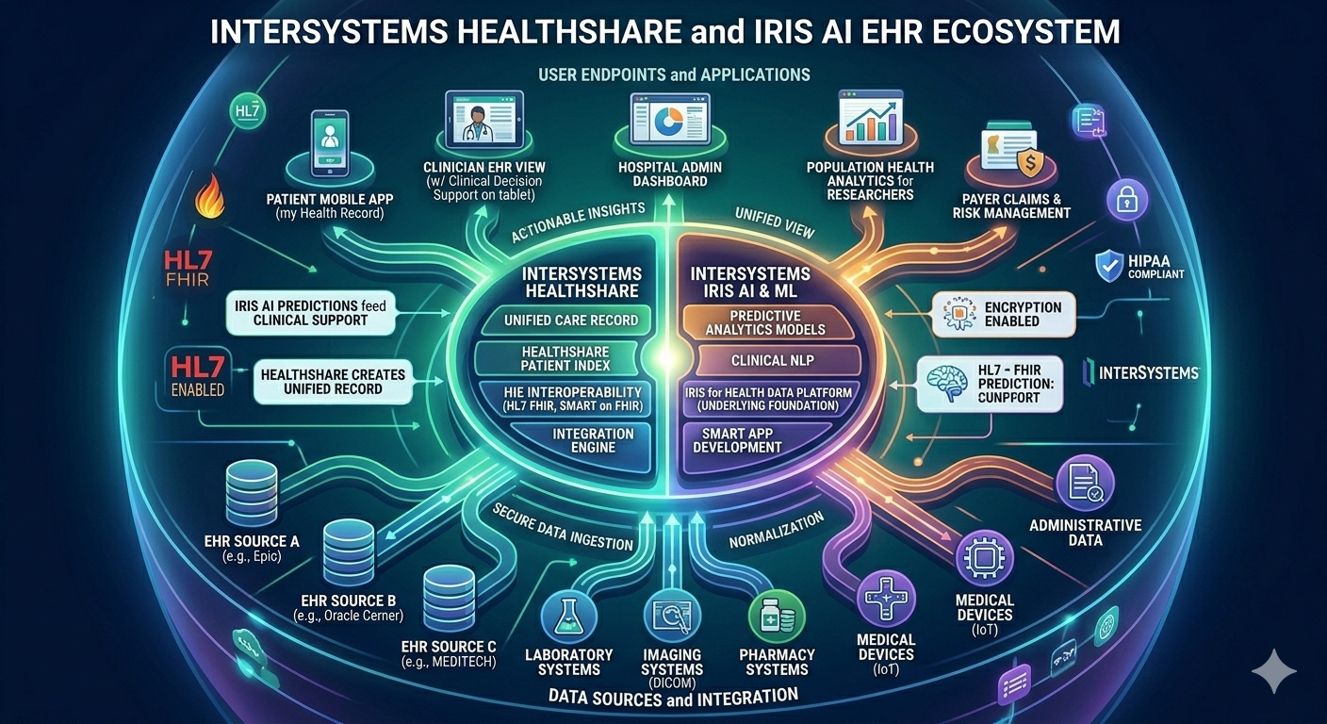
  - The Ecosystem portrayed using InterSystems’ HealthShare/IRIS AI HER
In order to achieve a Sovereign Mesh, the following core capabilities are necessary:

Core Architectural Components
1. The “Bouncer Gateway”
The "Bouncer" is the localized enforcement engine residing on edge hardware (e.g., HP or Dell Blades Server fleet).
- Sovereignty Enforcement: Employs metadata tagging to ensure compliance with laws like WV SB17, preventing PHI from leaving its legal jurisdiction.
- Agentic Logic: Built with Kotlin Multiplatform (KMP) for consistent security logic across mobile and desktop environments.
2. Sovereign Mesh Interoperability Protocol (SMIP)
A P2P standard for Secure Federated Inference. It enables:
- Query Encapsulation: Clinical questions are sent via ephemeral "Query Agents."
- Zero-Knowledge Collaboration: Results are generated inside a Hardware Secure Enclave (e.g., a TEE) at the destination node. No raw data is ever exchanged.

What these building blocks provide the Sovereign Mesh architecture is a solid foundation for secure decentralized end-point management down to any hospital, clinic, end user mobile device, land, sea and air mobilized platforms. Here we summarize:

Control Area | Implementation Mechanism | Evidence Source
Logical Access | Bouncer Certificate Handshake | P2P TLS Handshake Logs
Data Residency | WV-SB17 Metadata Enforcement | Bouncer Routing Audit Trail
Change Mgt | Signed AI Model Fingerprints (Hashes) | Central Compliance Dashboard
Incident Resp | "Silent Island" Offline Protocol | Secure Enclave Attestation

Stay tuned for the next Blog on how to convince stakeholders and executives, users, physicians, nurses and clinical staff how and why this is the roadmap to the future of AI EHR systems in a Neural Network as we transition from “Data Custodians” to “Data Sovereigns” as you will see by the announcements from software companies and vendors that are already heading down this path to offer products and services that are a part of the solution.

